Marijuana Monopolies Considered in Ohio – Vote No on Issue 3

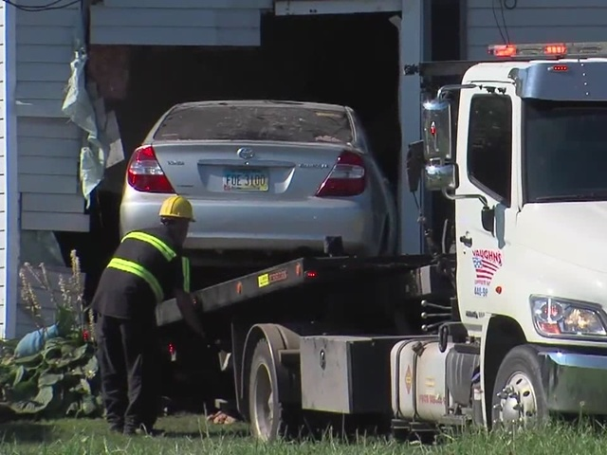

Why was a driver be so impaired that she drove right into a house and kills the resident? Weed was found in the driver’s car immediately after the crash. Drug testing has found that the THC was a factor. Now two children live without their mother and the driver escaped harm. It happened near Lorain, Ohio, on July 28. If the ResponsibleOhio PAC gets its way and marijuana is legal in the state, Ohioans can expect more terrible accidents and absurdities such as this one.

Grass roots groups have organized to defeat marijuana legalization in Ohio under a common banner, Ohioans Against Marijuana Monopolies. Their campaign is called No on Issue 3.

Ohioans are fighting against a private organization made up of syndicates of wealthy investors who would acquire the exclusive rights to grow, manufacture and sell marijuana to marijuana stores in Ohio The investors propose to acquire these rights by amending the Ohio Constitution through a ballot vote on November 3, 2015.

The anti-pot groups would love to have the money and the funding of the marijuana Political Action Committees with their donors. Ohioans Against Marijuana Monopolies will need to raise money quickly. The marijuana industry and lobbyists like to say that anti-pot groups are funded by the pharmaceutical and alcohol industries, a theory that couldn’t be further than the truth. Here’s a place to donate to the the groups working against legalizing pot in Ohio.
The Ohio Marijuana Monopoly envisioned by the investor-run group, known as ResponsibleOhio PAC, began asking for $4 million from individuals and soliciting its investors by promising them lavish profits. Any marijuana bought by the retail stores would have to be purchased from one of the 10 grow sites. The stores are promoted as opportunities for small business owners. The investors suggested there would be about 1000 stores (nearly 3x the number of state liquor stores) across Ohio focusing on sales of recreational marijuana in the form of joints and/or edibles such as cookies, brownies and candies. They even locked into the amendment their own sweetheart tax rates. Individual investors were told half their investment would go to pay for the ballot, and half to buy the cultivation properties. The group was raising $28 million for this strategic plan.
The names of many the investors are hidden by corporate shields that conceal their identities. Yet, if Issue 3 is approved, these investors would own the exclusive option to grow and cultivate all marijuana at the 10 designated sites. Corporations representing the investors have already purchased the sites.
Ohio has no “medical” marijuana program, so the group is sidestepping the usual approach the marijuana industry has taken to legitimize the use of marijuana in their state-by-state legalization effort.

Big Money Backs Legalization Efforts
Back in 1998, Gen. Barry McCaffrey, former Drug Czar, testifying before the Senate Committee on the Judiciary, warned
“There is a carefully camouflaged, exorbitantly funded, well-heeled elitist group whose ultimate goal is legalize drug use in the United States.” The dreams of this group are coming to pass, as the West Coast of Weed is a reality which wants to spread throughout USA.

Cleveland insurance executive Peter Lewis and George Soros, founder of Soros Fund Management, donated millions upon millions of dollars aimed at changing drug laws across the nation over the last 20 years. Soros’s baby, the Drug Policy Alliance and Drug Policy Action (DPA).are committed to goal of legalizing all drugs. The Marijuana Policy Project (MPP) founded in 1995 has become a political powerhouse with its robust fundraising and effective campaign messaging. It has infiltrated many state legislatures and the halls of Congress. Billionaire Peter Lewis, the head of Progressive Insurance, funded the group.

Peter Lewis was an Ohio resident until he died in late 2013. Before he died, Lewis also made a major donation to the Brooking Institution, in order to fund academic scholarship supportive of legalizing marijuana. He also donated of money to the successful Amendment 91 to legalize marijuana in Oregon. His children added more money to the campaign after his death, which was additional to the Soros money. In 2012, marijuana Oregon’s legalization ballot was unsuccessful, because MPP and Soros’s DPA had decided to give money to the winning ballots in Washington and Colorado

Who’s Against Marijuana Monopolies and Pot Legalization?
Ohio Governor John Kasich is against marijuana legalization, along with the Treasurer, Auditor, Secretary of State, Attorney General and House Speaker. Leading newspaper editorial boards and most statewide elected official oppose the plan. Many members of both political parties are upset. Deep opposition to Issue 3 arose even before it was certified to the ballot in mid-August
Children’s health advocates, doctors, hospitals, civic leaders, parents, educators, farmers, other business people, chambers of commerce, law enforcement personnel, addiction counselors and faith leaders are very upset about the potential for increased drug use and abuse that comes with marijuana legalization.
Issue 3 also allows every Ohio adult to grow pot at hom and possess more than half a pould of marijuana for recreational use at all times. A half of pound of marijuana is equivalent to 500 marijuana joints. What that lareg of an amount to be allowed at one time and the creation of a monopoly, no wonder so many groups have begun to speak out against this proposed ballot initiative.

